**PROJECT REPORT ON**

**AIRLINE TICKET BOOKING SYSTEM**

***Prepared by***

***Sikandar Lakra (Roll No: - 18700220040)***

***Md Hussian Ashraf (Roll No: - 18700220059)***

***Ayush Jaiswal (Roll No: - 18700120079)***

***Prashant Rajaji (Roll No: - 18700120058)***

***Academic Year: 2021-2022***

SUBMITTED IN PARTIAL FULLFILLMENT OF THE REQUIREMENT FOR THE DEGREE BACHELOR OF TECHOLOGY (COMPUTER SCIENCE & ENGINEERING**)**

**TECHNO INTERNATIONAL NEW TOWN**

**Department of Computer Science & Engineering**

**Block-DG, Action Area 1, New Town, Kolkata -700156, West Bengal, India**

**CERTIFICATE**

This is to certify that the project report entitled “Airline Ticket Booking System” has been prepared by the following students of the Department of Computer Science & Engineering in partial fulfillment for the degree of Bachelor of Technology(B.Tech.) in Computer Science & Engineering which is affiliated to Maulana Abul Kalam Azad University of Technology, West Bengal (Formerly known as West Bengal University of Technology) in the academic year 2021-2022

It is to be understood that by this approval, the undersigned does not necessarily endorse or approve any statement made, opinion expressed or conclusion drawn thereof, but approves the report only for the purpose for which it has been submitted.

|  |  |  |
| --- | --- | --- |
| **Sl No.** | **Name** | **Roll Number** |
| 1 | Sikandar Lakra | 18700220040 |
| 2 | Md Hussian Ashraf | 18700220059 |
| 3 | Ayush Jaiswal | 18700120079 |
| 4 | Prashant Rajaji | 18700120058 |

………………………………………….

Prof. Bikash Sadhukhan,

HOD, Computer Science & Engineering,

Techno International New Town

**ABSTRACT**

The “Flight Ticket Booking System” has been developed to override the problem prevailing in the practicing manual system . This project “Airline Reservation System” is about flight ticket booking and managing flight databases as admin. This project report presents the development and implementation of an Airline Ticket Booking System. The system is designed to streamline the process of booking airline tickets, allowing customers to make flight reservations online. The system also allows for the handling of customer information and reservations.

Airline reservation systems are used to maintain records of flight schedules and passenger reservations and seat assignments and ticket purchases. The modern airline reservation system also serves customer needs from beginning to end of each customer's reserved flight, therefore laying out management tasks for each flight.

**CONTENTS**

**Page No.**

1. **INTRODUCTION ………………………………..………………… ……**
2. **PROBLEM DEFINITION………………………………………………**
3. **ARCHITECTURE & DETAILED WORKING…………………………**
4. **CONCLUSION ……………………………………………………………**
5. **FUTURE SCOPE OF PROJECT ………………………………………**
6. **BIBLIOGRAPHY…………………………………………………………**

**LIST OF FIGURES**

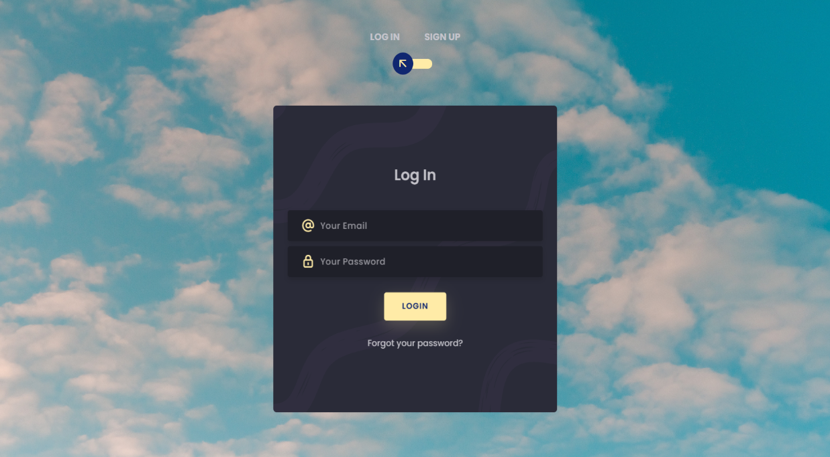

Figure 1.1 Login Page

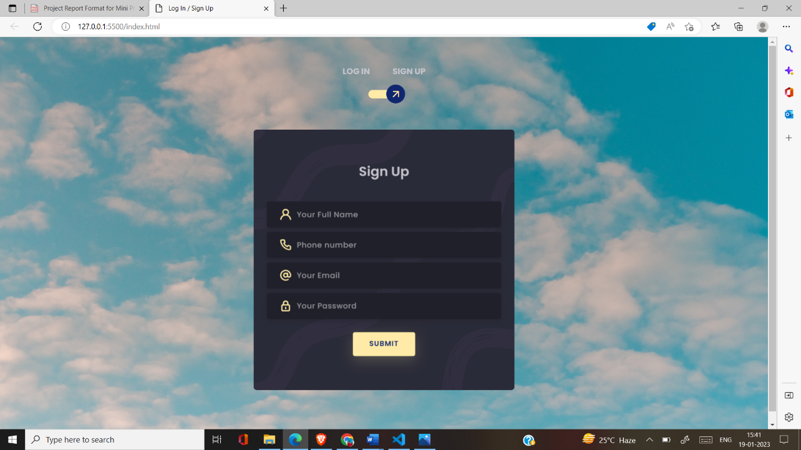

Figure 1.2 Sign-Up Page

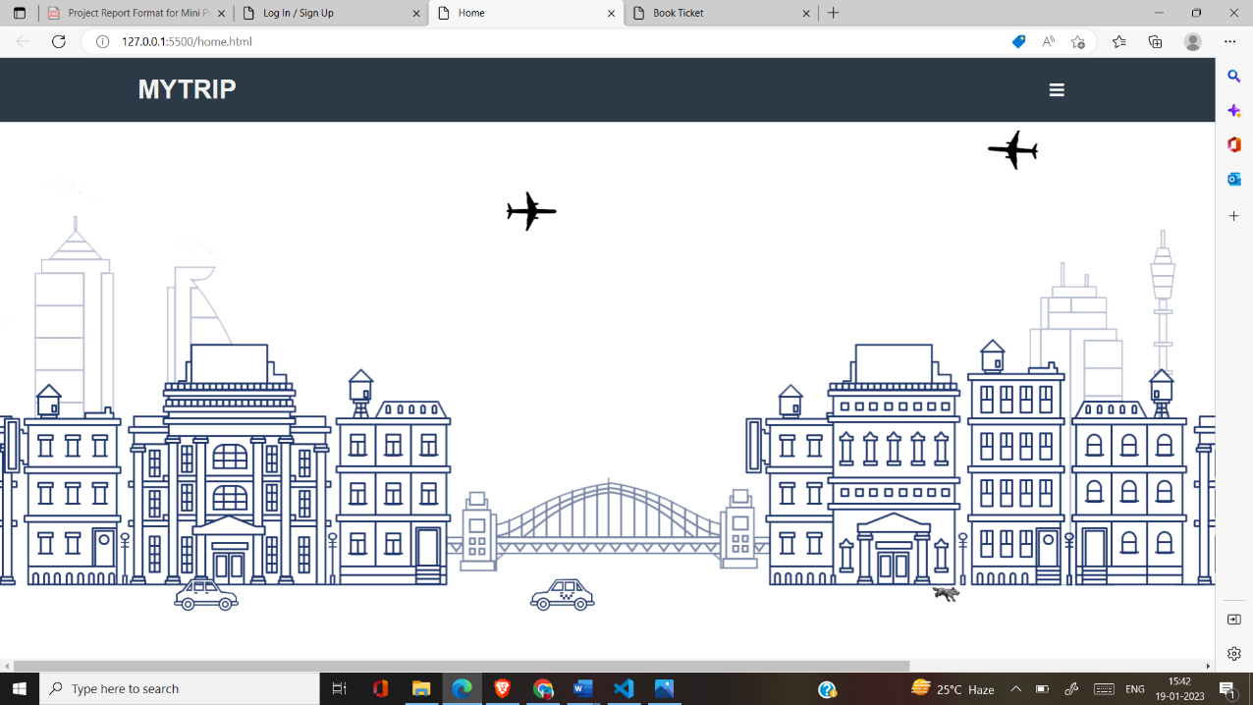

Figure 2.1 Home Page

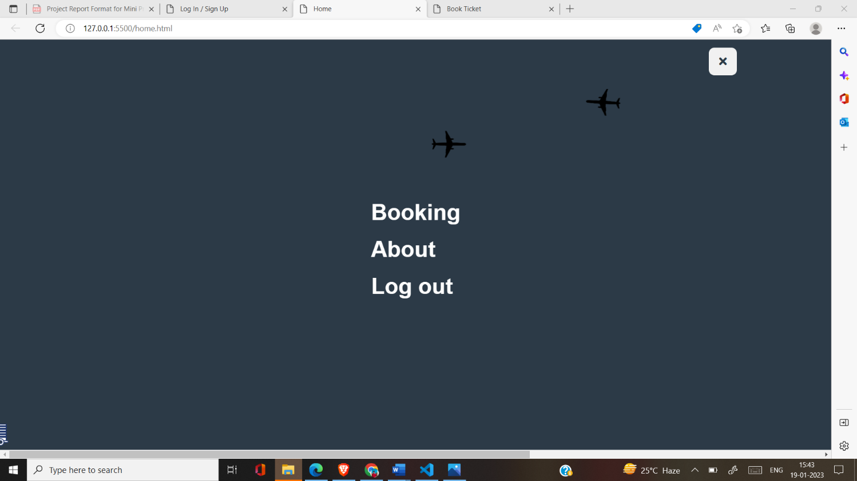

Figure 2.2 Home Page

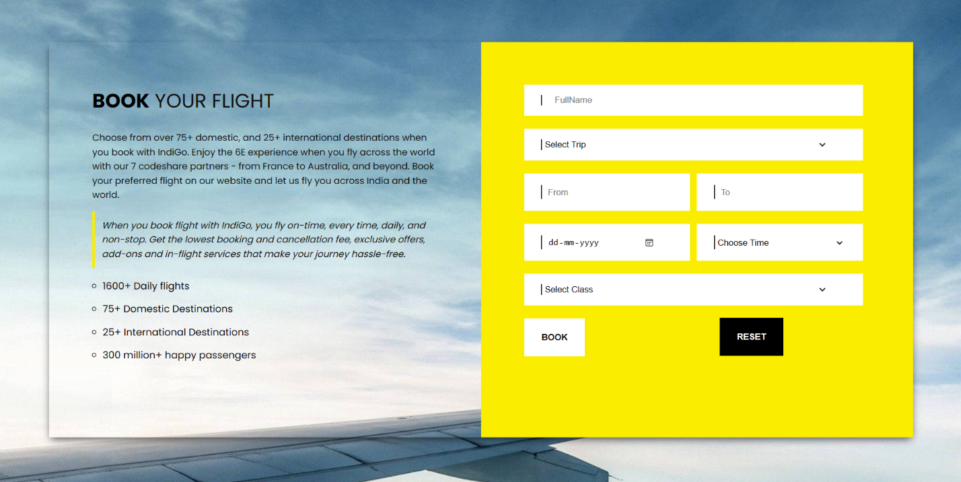

Figure 3 Booking Page

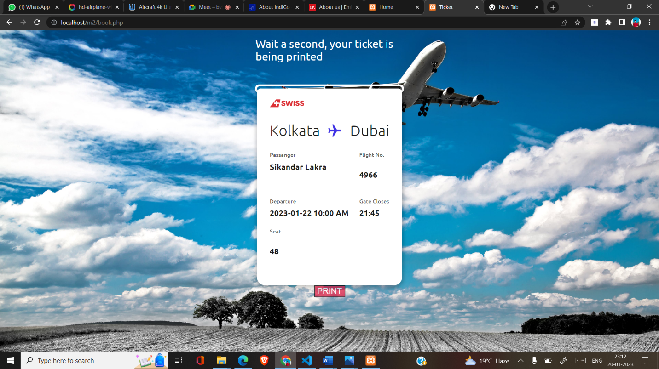

Figure 4 Ticket Page

**INTRODUCTION**

The Airline Ticket Booking System is designed to automate the process of booking airline tickets. The system allows customers to log in, signup, and make reservations online. The system also allows for handling customer information and reservations. This system will help reduce airline employees' workload and improve the booking process's efficiency for customers. The main objective of this project is to design a dynamic, responsive website and an online framework for Airline Ticket Booking System or web application with full-fledged logic and environment using new trending technologies in the market with maximum functionalities, efficiency, maximum optimal speed on web and one key feature it must be informative.

**PROBLEM DEFINITION**

The current process of booking airline tickets is time-consuming and often involves standing in long lines or waiting on hold to speak with a customer service representative. Additionally, customers are often required to provide a significant amount of personal information in order to make a reservation. The Airline Ticket Booking System aims to address these issues by providing a user-friendly interface that allows customers to make flight reservations online quickly and easily.

**ARCHITECTURE**

The Airline Ticket Booking System is built using a combination of technologies, including HTML, CSS, JavaScript, and PHP. The system is designed to be compatible with multiple browsers and devices and is responsive to different screen sizes. The system is built on a three-tier architecture, consisting of a presentation layer, a business logic layer, and a data storage layer.

The presentation layer is responsible for displaying information to the user, and it is built using HTML, CSS, and JavaScript. The business logic layer is responsible for handling the underlying logic and functionality of the system, and it is built using PHP. The data storage layer is responsible for storing and retrieving data, and it is built using a MySQL database.

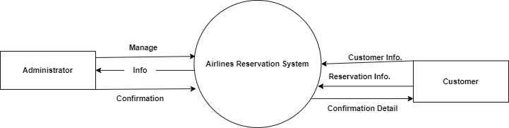

Level-0 DFD of Airline Ticket Booking System

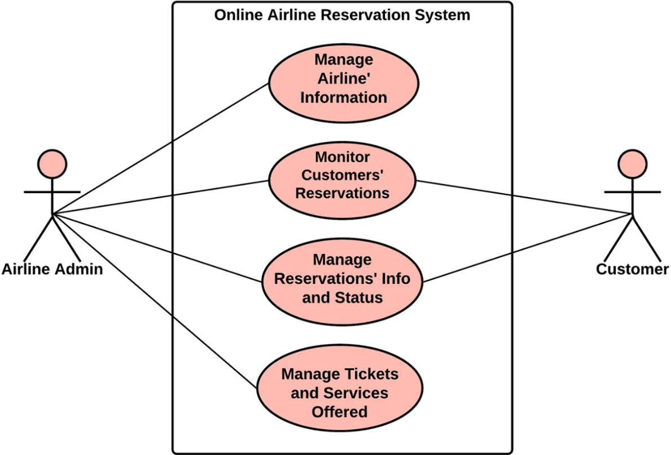

Use-Case Diagram of Airline Ticket Booking System

**DETAILED WORKING**

The user is provided with a login page if the user is not registered then first the user must register himself with email, password, and some basic details, after successful registration he will be redirected to the login page, and there the user must type registered email and password to authenticate the user. If the Wrong email and password are given, the user will get an alert message “wrong email or password!” and it will ask for the correct email and password, if the email and password are matched in the database then the user will be redirected to the ticket booking page. There he must provide arrival, departure, date, class, and trip to book a ticket. After the successful booking of a ticket, the user will get a ticket. The system will then confirm the reservation and generate a ticket for the user which he can print. After logout, the user will be redirected to the login page.

**Index.html**

<!DOCTYPE html>

<html lang="en">

<head>

    <meta charset="UTF-8">

    <title> Log In / Sign Up </title>

    <link rel='stylesheet' href='https://cdnjs.cloudflare.com/ajax/libs/twitter-bootstrap/4.5.0/css/bootstrap.min.css'>

    <link rel='stylesheet' href='https://unicons.iconscout.com/release/v2.1.9/css/unicons.css'><link rel ="stylesheet" href="./index.css">

</head>

<body>

    <div class="section">

        <div class="container">

            <div class="row full-height justify-content-center">

                <div class="col-12 text-center align-self-center py-5">

                    <div class="section pb-5 pt-5 pt-sm-2 text-center">

                        <h6 class="mb-0 pb-3"><span>Log In </span><span>Sign Up</span></h6>

                        <input class="checkbox" type="checkbox" id="reg-log" name="reg-log"/>

                        <label for="reg-log"></label>

                        <div class="card-3d-wrap mx-auto">

                            <div class="card-3d-wrapper">

                                <div class="card-front">

                                    <div class="center-wrap">

                                        <form action="login.php" method="post">

                                        <div class="section text-center">

                                            <h4 class="mb-4 pb-3">Log In</h4>

                                            <div class="form-group">

                                                <input type="email" name="logemail" class="form-style" placeholder="Your Email" id="logemail" autocomplete="off">

                                                <i class="input-icon uil uil-at"></i>

                                            </div>

                                            <div class="form-group mt-2">

                                                <input type="password" name="logpass" class="form-style" placeholder="Your Password" id="logpass" autocomplete="off">

                                                <i class="input-icon uil uil-lock-alt"></i>

                                            </div>

                                            <input type="submit" class="btn mt-4" value="login">

                                            <p class="mb-0 mt-4 text-center"><a href="#0" class="link">Forgot your password?</a></p>

                                        </div>

                                        </form>

                                    </div>

                                </div>

                                <div class="card-back">

                                    <div class="center-wrap">

                                        <form action="signup.php" method="post">

                                        <div class="section text-center">

                                            <h4 class="mb-4 pb-3">Sign Up</h4>

                                            <div class="form-group">

                                                <input type="text" name="logname" class="form-style" placeholder="Your Full Name" id="logname" autocomplete="off" required>

                                                <i class="input-icon uil uil-user"></i>

                                            </div>

                                            <div class="form-group mt-2">

                                                <input type="text" name="logphone" class="form-style" placeholder="Phone number" id="logphone" autocomplete="off" required>

                                                <i class="input-icon uil uil-phone-alt"></i>

                                            </div>

                                            <div class="form-group mt-2">

                                                <input type="email" name="logemail" class="form-style" placeholder="Your Email" id="logemail" autocomplete="off" required>

                                                <i class="input-icon uil uil-at"></i>

                                            </div>

                                            <div class="form-group mt-2">

                                                <input type="password" name="logpass" class="form-style" placeholder="Your Password" id="logpass" autocomplete="off" required>

                                                <i class="input-icon uil uil-lock-alt"></i>

                                            </div>

                                            <input type="submit" class="btn mt-4" value="submit">

                                        </div>

                                    </form>

                                    </div>

                                </div>

                            </div>

                        </div>

                    </div>

                </div>

            </div>

        </div>

    </div>

<script src="./script.js"></script>

</body>

</html>

**Index.css**

@import url('https://fonts.googleapis.com/css?family=Poppins:400,500,600,700,800,900');

body{

  font-family: 'Poppins', sans-serif;

  font-weight: 300;

  font-size: 15px;

  line-height: 1.7;

  color: #c4c3ca;

  background: url("login.jpg");

  background-size: 100% 100%;

  overflow-x: hidden;

}

a {

  cursor: pointer;

  transition: all 200ms linear;

}

a:hover {

  text-decoration: none;

}

.link {

  color: #c4c3ca;

}

.link:hover {

  color: #ffeba7;

}

p {

  font-weight: 500;

  font-size: 14px;

  line-height: 1.7;

}

h4 {

  font-weight: 600;

}

h6 span{

  padding: 0 20px;

  text-transform: uppercase;

  font-weight: 700;

}

.section{

  position: relative;

  width: 100%;

  display: block;

}

.full-height{

  min-height: 100vh;

}

[type="checkbox"]:checked,

[type="checkbox"]:not(:checked){

  position: absolute;

  left: -9999px;

}

.checkbox:checked + label,

.checkbox:not(:checked) + label{

  position: relative;

  display: block;

  text-align: center;

  width: 60px;

  height: 16px;

  border-radius: 8px;

  padding: 0;

  margin: 10px auto;

  cursor: pointer;

  background-color: #ffeba7;

}

.checkbox:checked + label:before,

.checkbox:not(:checked) + label:before{

  position: absolute;

  display: block;

  width: 36px;

  height: 36px;

  border-radius: 50%;

  color: #ffeba7;

  background-color: #102770;

  font-family: 'unicons';

  content: '\eb4f';

  z-index: 20;

  top: -10px;

  left: -10px;

  line-height: 36px;

  text-align: center;

  font-size: 24px;

  transition: all 0.5s ease;

}

.checkbox:checked + label:before {

  transform: translateX(44px) rotate(-270deg);

}

.card-3d-wrap {

  position: relative;

  width: 500px;

  max-width: 100%;

  height: 500px;

  -webkit-transform-style: preserve-3d;

  transform-style: preserve-3d;

  perspective: 800px;

  margin-top: 60px;

}

.card-3d-wrapper {

  width: 100%;

  height: 100%;

  position:absolute;

  top: 0;

  left: 0;

  -webkit-transform-style: preserve-3d;

  transform-style: preserve-3d;

  transition: all 600ms ease-out;

}

.card-front, .card-back {

  width: 100%;

  height: 100%;

  background-color: #2a2b38;

  background-image: url('https://s3-us-west-2.amazonaws.com/s.cdpn.io/1462889/pat.svg');

  background-position: bottom center;

  background-repeat: no-repeat;

  background-size: 300%;

  position: absolute;

  border-radius: 6px;

  left: 0;

  top: 0;

  -webkit-transform-style: preserve-3d;

  transform-style: preserve-3d;

  -webkit-backface-visibility: hidden;

  -moz-backface-visibility: hidden;

  -o-backface-visibility: hidden;

  backface-visibility: hidden;

}

.card-back {

  transform: rotateY(180deg);

}

.checkbox:checked ~ .card-3d-wrap .card-3d-wrapper {

  transform: rotateY(180deg);

}

.center-wrap{

  position: absolute;

  width: 100%;

  padding: 0 35px;

  top: 50%;

  left: 0;

  transform: translate3d(0, -50%, 35px) perspective(100px);

  z-index: 20;

  display: block;

}

.form-group{

  position: relative;

  display: block;

    margin: 0;

    padding: 0;

}

.form-style {

  padding: 13px 20px;

  padding-left: 55px;

  height: 48px;

  width: 100%;

  font-weight: 500;

  border-radius: 4px;

  font-size: 14px;

  line-height: 22px;

  letter-spacing: 0.5px;

  outline: none;

  color: #c4c3ca;

  background-color: #1f2029;

  border: none;

  -webkit-transition: all 200ms linear;

  transition: all 200ms linear;

  box-shadow: 0 4px 8px 0 rgba(21,21,21,.2);

}

.form-style:focus,

.form-style:active {

  border: none;

  outline: none;

  box-shadow: 0 4px 8px 0 rgba(21,21,21,.2);

}

.input-icon {

  position: absolute;

  top: 0;

  left: 18px;

  height: 48px;

  font-size: 24px;

  line-height: 48px;

  text-align: left;

  color: #ffeba7;

  -webkit-transition: all 200ms linear;

    transition: all 200ms linear;

}

.form-group input:-ms-input-placeholder  {

  color: #c4c3ca;

  opacity: 0.7;

  -webkit-transition: all 200ms linear;

    transition: all 200ms linear;

}

.form-group input::-moz-placeholder  {

  color: #c4c3ca;

  opacity: 0.7;

  -webkit-transition: all 200ms linear;

    transition: all 200ms linear;

}

.form-group input:-moz-placeholder  {

  color: #c4c3ca;

  opacity: 0.7;

  -webkit-transition: all 200ms linear;

    transition: all 200ms linear;

}

.form-group input::-webkit-input-placeholder  {

  color: #c4c3ca;

  opacity: 0.7;

  -webkit-transition: all 200ms linear;

    transition: all 200ms linear;

}

.form-group input:focus:-ms-input-placeholder  {

  opacity: 0;

  -webkit-transition: all 200ms linear;

    transition: all 200ms linear;

}

.form-group input:focus::-moz-placeholder  {

  opacity: 0;

  -webkit-transition: all 200ms linear;

    transition: all 200ms linear;

}

.form-group input:focus:-moz-placeholder  {

  opacity: 0;

  -webkit-transition: all 200ms linear;

    transition: all 200ms linear;

}

.form-group input:focus::-webkit-input-placeholder  {

  opacity: 0;

  -webkit-transition: all 200ms linear;

    transition: all 200ms linear;

}

.btn{

  border-radius: 4px;

  height: 44px;

  font-size: 13px;

  font-weight: 600;

  text-transform: uppercase;

  -webkit-transition : all 200ms linear;

  transition: all 200ms linear;

  padding: 0 30px;

  letter-spacing: 1px;

  display: -webkit-inline-flex;

  display: -ms-inline-flexbox;

  display: inline-flex;

  -webkit-align-items: center;

  -moz-align-items: center;

  -ms-align-items: center;

  align-items: center;

  -webkit-justify-content: center;

  -moz-justify-content: center;

  -ms-justify-content: center;

  justify-content: center;

  -ms-flex-pack: center;

  text-align: center;

  border: none;

  background-color: #ffeba7;

  color: #102770;

  box-shadow: 0 8px 24px 0 rgba(255,235,167,.2);

}

.btn:active,

.btn:focus{

  background-color: #102770;

  color: #ffeba7;

  box-shadow: 0 8px 24px 0 rgba(16,39,112,.2);

}

.btn:hover{

  background-color: #102770;

  color: #ffeba7;

  box-shadow: 0 8px 24px 0 rgba(16,39,112,.2);

}

.logo {

  position: absolute;

  top: 30px;

  right: 30px;

  display: block;

  z-index: 100;

  transition: all 250ms linear;

}

.logo img {

  height: 26px;

  width: auto;

  display: block;

}

section{

    position: relative;

    height: 100vh;

    width: 100%;

    background: url("./login.jpg");

    background-size: cover;

    background-position: center center;

}

**Login.php**

<?php

    $connection=mysqli_connect("localhost", "root", "", "signup");

    if($connection==false)

    {

        echo "error!";

    }

    $email=$_POST['logemail'];

    $password=$_POST['logpass'];

    $sql="SELECT * FROM `passengers`";

    $result=mysqli_query($connection, $sql);

    $num=mysqli_num_rows($result);

    while ($row=mysqli_fetch_assoc($result)) {

        if ($row['email']==$email && $row['password']==$password) {

            header('location: home.html');

            die();

        }

    }

    header('location: index.html');

?>

**Signup.php**

<?php

    $connection=mysqli_connect("localhost", "root", "", "signup");

    if($connection==false)

    {

        echo "error!";

    }

    $fullname=$_POST['logname'];

    $phone=$_POST['logphone'];

    $email=$_POST['logemail'];

    $password=$_POST['logpass'];

    $sql="INSERT INTO `passengers`(`id`, `fullName`, `phoneNo`, `email`, `password`) VALUES ('','$fullname','$phone','$email','$password')";

    if (mysqli_query($connection, $sql)) {

       // echo "Register Successful";

        //echo "<br><br> <a style = 'text-decoration: none;' href = 'index.html'> Login </a>";

        header('location: index.html');

    }

    else{

        echo "Error";

    }

?>

**Home.html**

<!DOCTYPE html>

<html lang="en">

  <head>

    <meta charset="UTF-8" />

    <meta name="viewport" content="width=device-width, initial-scale=1.0" />

    <title>Home</title>

    <script src="https://cdnjs.cloudflare.com/ajax/libs/jquery/3.6.0/jquery.min.js"></script>

    <link

      rel="stylesheet"

      href="https://cdnjs.cloudflare.com/ajax/libs/font-awesome/5.15.3/css/all.min.css"

    />

    <link rel="stylesheet" href="home.css" />

  </head>

  <body>

      <img src="airplane1.png" class="airplane1">

        <img src="airplane2.png" class="airplane2">

        <img src="hotel.png" class="hotel">

        <img src="car1.png" class="car1">

        <img src="car2.png" class="car2">

        <img src="car3.png" class="car3">

        <img src="car4.png" class="car4">

        <img src="dog.gif" class="dog_1">

        <img src="cloud.png" class="cloud">

        <img src="cloud.png" class="cloud_2">

        <img src="cloud.png" class="cloud_3">

        <img src="cloud.png" class="cloud_4">

    <header>

      <div class="inner-width">

        <h1>MYTRIP</h1>

        <div class="menu-icon">

          <i class="fas fa-bars"></i>

        </div>

      </div>

    </header>

    <div class="navigation-menu">

      <nav>

        <ul>

          <li><a href="book.html" target="_blank">Booking</a></li>

          <li><a href="about.html" target="_blank">About</a></li>

          <li><a href="index.html">Log out</a></li>

        </ul>

      </nav>

    </div>

    <script>

      $(".menu-icon").click(function () {

        $(this).toggleClass("active");

        $(".navigation-menu").toggleClass("active");

        $(".menu-icon i").toggleClass("fa-times");

      });

    </script>

  </body>

</html>

**Home.css**

* {

    margin: 0;

    padding: 0;

    font-family: "Ubuntu", sans-serif;

    text-decoration: none;

    list-style: none;

    box-sizing: border-box;

  }

  header {

    background: #2c3a47;

  }

  .inner-width {

    max-width: 80%;

    display: flex;

    align-items: center;

    justify-content: space-between;

    padding: 14px 20px;

    margin: auto;

    color: #f1f1f1;

  }

  .menu-icon {

    width: 50px;

    height: 50px;

    background: #2c3a47;

    color: #fff;

    text-align: center;

    line-height: 50px;

    font-size: 20px;

    z-index: 3;

    border-radius: 10px;

    cursor: pointer;

    transition: 0.2s linear;

  }

  .menu-icon:hover {

    opacity: 0.9;

    transform: scale(1.1);

    background: #7a49ff;

  }

  .navigation-menu {

    position: fixed;

    width: 100%;

    height: 100vh;

    background: #2c3a47;

    top: 0;

    right: -100%;

    display: flex;

    align-items: center;

    justify-content: center;

    transition: 0.6s;

    z-index: 2;

  }

  .navigation-menu nav {

    display: grid;

  }

  .navigation-menu li {

    margin: 20px 0;

    overflow: hidden;

  }

  .navigation-menu a {

    color: #fff;

    font-size: 40px;

    font-weight: 700;

    position: relative;

    display: inline-block;

    transform: translateY(40px);

  }

  .navigation-menu a::before {

    content: "";

    position: absolute;

    width: 0;

    height: 15px;

    background: #7a49ff;

    bottom: 0;

    left: 0;

    z-index: -1;

    transition: 0.2s linear;

  }

  .navigation-menu a:hover::before {

    width: 100%;

  }

  p {

    max-width: 80%;

    margin: auto;

    padding: 40px 0;

    font-size: 18px;

    line-height: 1.4em;

    text-align: justify;

  }

  .menu-icon.active {

    background: #f1f1f1;

    color: #2c3a47;

  }

  .navigation-menu.active {

    right: 0;

  }

  .navigation-menu.active a {

    transform: translateY(0);

    transition: 0.6s linear;

  }

  .navigation-menu.active li:nth-child(1) a {

    transition-delay: 0.2s;

  }

  .navigation-menu.active li:nth-child(2) a {

    transition-delay: 0.4s;

  }

  .navigation-menu.active li:nth-child(3) a {

    transition-delay: 0.6s;

  }

  .hotel {

    position: absolute;

    bottom: 6vw;

    left: 0;

    width: 100%;

    z-index: 2;

  }

  .airplane1 {

    position: absolute;

    bottom: 70%;

    -webkit-animation: drive 9s;

            animation: drive 9s;

    -webkit-animation-iteration-count: infinite;

            animation-iteration-count: infinite;

    width: 80px;

    z-index: 3;

  }

  .airplane2 {

    position: absolute;

    bottom: 80%;

    -webkit-animation: drive_2 9s;

            animation: drive_2 9s;

    -webkit-animation-iteration-count: infinite;

            animation-iteration-count: infinite;

    width: 80px;

    z-index: 3;

  }

  .car1 {

    position: absolute;

    bottom: 8%;

    -webkit-animation: drive 15s;

            animation: drive 15s;

    -webkit-animation-iteration-count: infinite;

            animation-iteration-count: infinite;

    width: 80px;

    z-index: 3;

  }

  .car1 {

    position: absolute;

    bottom: 8%;

    -webkit-animation: drive 15s;

            animation: drive 15s;

    -webkit-animation-iteration-count: infinite;

            animation-iteration-count: infinite;

    width: 80px;

    z-index: 3;

  }

  .car2 {

    position: absolute;

    bottom: 5%;

    -webkit-animation: drive 10s;

            animation: drive 10s;

    -webkit-animation-iteration-count: infinite;

            animation-iteration-count: infinite;

    width: 80px;

    z-index: 3;

  }

  .car3 {

    position: absolute;

    bottom: 8%;

    -webkit-animation: drive_2 20s;

            animation: drive_2 20s;

    -webkit-animation-iteration-count: infinite;

            animation-iteration-count: infinite;

    width: 80px;

    z-index: 3;

  }

  .car4 {

    position: absolute;

    bottom: 1%;

    -webkit-animation: drive_2 12s;

            animation: drive_2 12s;

    -webkit-animation-iteration-count: infinite;

            animation-iteration-count: infinite;

    width: 80px;

    z-index: 3;

  }

  .dog_1 {

    height: 6%;

    position: absolute;

    bottom: 9%;

    -webkit-animation: drive 20s;

            animation: drive 20s;

    -webkit-animation-iteration-count: infinite;

            animation-iteration-count: infinite;

    z-index: 3;

  }

  .cloud {

    position: absolute;

    top: -100px;

    -webkit-animation: cloud_1 50s;

            animation: cloud_1 50s;

    -webkit-animation-iteration-count: infinite;

            animation-iteration-count: infinite;

    width: 800px;

    z-index: 1;

  }

  .cloud_2 {

    position: absolute;

    bottom: 50%;

    -webkit-animation: cloud_2 60s;

            animation: cloud_2 60s;

    -webkit-animation-iteration-count: infinite;

            animation-iteration-count: infinite;

    width: 500px;

    z-index: 1;

  }

  .cloud_3 {

    position: absolute;

    bottom: 60%;

    -webkit-animation: cloud_2 30s;

            animation: cloud_2 30s;

    -webkit-animation-iteration-count: infinite;

            animation-iteration-count: infinite;

    width: 500px;

    z-index: 1;

  }

  .cloud_4 {

    position: absolute;

    bottom: 70%;

    -webkit-animation: cloud_2 70s;

            animation: cloud_2 70s;

    -webkit-animation-iteration-count: infinite;

            animation-iteration-count: infinite;

    width: 500px;

    z-index: 1;

  }

  @-webkit-keyframes drive {

    from {

      -webkit-transform: translateX(-100px);

              transform: translateX(-100px);

    }

    to {

      -webkit-transform: translateX(1950px);

              transform: translateX(1950px);

    }

  }

  @keyframes drive {

    from {

      -webkit-transform: translateX(-100px);

              transform: translateX(-100px);

    }

    to {

      -webkit-transform: translateX(1950px);

              transform: translateX(1950px);

    }

  }

  @-webkit-keyframes drive_2 {

    from {

      -webkit-transform: translateX(1950px);

              transform: translateX(1950px);

    }

    to {

      -webkit-transform: translateX(-200px);

              transform: translateX(-200px);

    }

  }

  @keyframes drive_2 {

    from {

      -webkit-transform: translateX(1950px);

              transform: translateX(1950px);

    }

    to {

      -webkit-transform: translateX(-200px);

              transform: translateX(-200px);

    }

  }

  @-webkit-keyframes cloud_1 {

    from {

      -webkit-transform: translateX(1900px);

              transform: translateX(1900px);

    }

    to {

      -webkit-transform: translateX(-900px);

              transform: translateX(-900px);

    }

  }

  @keyframes cloud_1 {

    from {

      -webkit-transform: translateX(1900px);

              transform: translateX(1900px);

    }

    to {

      -webkit-transform: translateX(-900px);

              transform: translateX(-900px);

    }

  }

  @-webkit-keyframes cloud_2 {

    from {

      -webkit-transform: translateX(1900px);

              transform: translateX(1900px);

    }

    to {

      -webkit-transform: translateX(-500px);

              transform: translateX(-500px);

    }

  }

  @keyframes cloud_2 {

    from {

      -webkit-transform: translateX(1900px);

              transform: translateX(1900px);

    }

    to {

      -webkit-transform: translateX(-500px);

              transform: translateX(-500px);

    }

  }

**Book.html**

<!DOCTYPE html>

<html lang="en">

  <head>

    <meta charset="UTF-8" />

    <title>Book Ticket</title>

    <meta name="viewport" content="width=device-width, initial-scale=1.0">

    <link href="https://maxcdn.bootstrapcdn.com/font-awesome/4.7.0/css/font-awesome.min.css" rel="stylesheet">

    <link rel="stylesheet" type="text/css" href="book.css">

  </head>

  <body>

    <div class="container">

      <p style="background-image: url('book.jpg');"></p>

      <div class="book">

        <div class="description">

          <h1><strong>Book</strong> your Flight</h1>

          <p>

            Choose from over 75+ domestic, and 25+ international destinations when you book with IndiGo. Enjoy the 6E experience when you fly across the world with our 7 codeshare partners - from France to Australia, and beyond. Book your preferred flight on our website and let us fly you across India and the world.

          </p>

          <div class="quote">

            <p>

              When you book flight with IndiGo, you fly on-time, every time, daily, and non-stop. Get the lowest booking and cancellation fee, exclusive offers, add-ons and in-flight services that make your journey hassle-free.

            </p>

          </div>

          <ul>

            <li>1600+ Daily flights</li>

            <li>75+ Domestic Destinations</li>

            <li>25+ International Destinations</li>

            <li>300 million+ happy passengers</li>

          </ul>

        </div>

        <div class="form">

          <form action="book.php" method="post">

            <div class="inpbox full">

              <span class="flaticon-globe"></span>

              <input type="text" name="fn" placeholder="FullName">

            </div>

            <div class="inpbox full">

              <span class="flaticon-trip"></span>

              <select id="trip" name="trip">

                <option value="">Select Trip</option>

                <option value="One Way">One Way</option>

                <option value="Round Trip">Round Trip</option>

                <option value="Multi-City">Multi-City</option>

              </select>

            </div>

            <div class="inpbox">

              <span class="flaticon-globe"></span>

              <input type="text" name="from" placeholder="From">

            </div>

            <div class="inpbox">

              <span class="flaticon-location"></span>

              <input type="text" name="to" placeholder="To">

            </div>

            <div class="inpbox">

              <span class="flaticon-calendar"></span>

              <input type="date" name="date" placeholder="Date">

            </div>

            <div class="inpbox">

              <span class="flaticon-time"></span>

              <select id="time" name="time">

                <option value="">Choose Time</option>

                <option value="10:00 AM">10:00 AM</option>

                <option value="04:45 PM">04:45 PM</option>

                <option value="08:30 PM">08:30 PM</option>

              </select>

            </div>

            <div class="inpbox full">

              <span class="flaticon-class"></span>

              <select id="class" name="class">

                <option value="">Select Class</option>

                <option value="Business">Business</option>

                <option value="Economy">Economy</option>

                <option value="Premium Economy">Premium Economy</option>

              </select>

            </div>

            <input type="submit" class="subt" value="Book">

            <input type="reset" class="rst" value="Reset">

          </form>

        </div>

      </div>

    </div>

  </body>

</html>

**Book.css**

@import url('https://fonts.googleapis.com/css?family=Poppins:400,500,600,700,800,900');

:root{

  --font-light: #100d0d;

  --primary-color: #FAED00;

}

body{

  font-family: 'Poppins', sans-serif;

  font-weight: 300;

  font-size: 15px;

  line-height: 1.7;

  color: #03020a;

  background-size: 100% 100%;

  overflow-x: hidden;

  display: flex;

  align-items: center;

  justify-content: center;

  padding: 3% 0;

  background: url("book.jpg");

}

.container {

  width: 90%;

  margin: 0 auto;

}

.book {

    box-shadow: 0px 5px 13px -3px rgba(0,0,0,0.75);

    display: flex;

    flex-wrap: wrap;

}

.description , .form{

    width: 40%;

    padding: 5%;

}

.description h1 {

    text-transform: uppercase;

    color: var(--font-light);

    font-weight: 400;

    margin-top: 0;

}

.description h1 strong{

  font-weight: 700;

  color: #000;

}

.description p {

    color: var(--font-light);

    font-size: 14px;

    line-height: 22px;

}

.quote p {

    font-style: italic;

    padding: 2%;

    border-left: 4px solid var(--primary-color);

}

.description ul {

    padding-left: 16px;

    list-style: circle;

}

.description ul li{

    margin: 10px 0;

}

.form{

  background: var(--primary-color);

}

.form form{

  color: var(--font-light);

    display: flex;

  flex-wrap: wrap;

}

.inpbox.full {

    width: 100%;

    background: #fff;

    padding: 3%;

    margin-bottom: 20px;

    display: flex;

    flex-wrap: wrap;

}

.inpbox span::before {

    margin-left: 0;

}

.inpbox span {

    padding-right: 10px;

    border-right: 2px solid var(--font-light);

}

.form select{

    border: 0;

    width: 90%;

    color: var(--font-light);

}

form input {

    border: 0;

    width: 74%;

    color: var(--font-light);

    padding: 0 4%;

}

.form select:focus, form input {

  outline: none;

}

.inpbox {

    width: 42%;

    background: #fff;

    padding: 3%;

    margin-bottom: 20px;

    margin-right: 2%;

}

.inrbox{

  width: 33%;

  color: #000;

}

.inrbox span{

  padding-right: 10px;

}

.inrbox span {

    border: 0;

    text-transform: uppercase;

    font-size: 12px;

}

.form input[type="radio"] {

    width: unset;

}

input.subt, input.rst{

  padding: 4% 5%;

  font-weight: 700;

  text-transform: uppercase;

  border: 0;

}

input.subt {

    position: relative;

    top:0px;

    right:0px;

    left:0px;

    bottom: 0px;

    margin-right: 90%;

    background: #fff;

}

input.rst {

  position: relative;

  top:-59px;

  right:0px;

  left:300px;

  bottom:0px;

    background: #000;

    color: #fff;

    margin-right: 90%;

}

**Book.php**

<?php

    $connection=mysqli_connect("localhost", "root", "", "signup");

    if($connection==false)

    {

        echo "error!";

    }

    $fullname=$_POST['fn'];

    $selectTrip=$_POST['trip'];

    $locationFrom=$_POST['from'];

    $locationTo=$_POST['to'];

    $selectDate=$_POST['date'];

    $selectTime=$_POST['time'];

    $selectClass=$_POST['class'];

    $sql="INSERT INTO `booking`(`id`, `fullName`, `trip`, `from`, `to`, `date`, `time`, `class`) VALUES ('','$fullname','$selectTrip','$locationFrom','$locationTo','$selectDate','$selectTime','$selectClass')";

    if (mysqli_query($connection, $sql)) {

?>

<!DOCTYPE html>

<html lang="en">

<head>

    <meta charset="UTF-8">

    <meta http-equiv="X-UA-Compatible" content="IE=edge">

    <meta name="viewport" content="width=device-width, initial-scale=1.0">

    <link rel="stylesheet" href="display.css">

    <title>Ticket</title>

    <style>

 @import url('https://fonts.googleapis.com/css?family=Ubuntu:300,400,500,700');

* {

    box-sizing: border-box;

  }

  html, body {

    height: 100%;

    margin: 0;

  }

  body {

    font-family: 'Ubuntu', sans-serif;

    background: url("login.jpg");

    background-size: 100% 100%;

    height: 100%;

    -webkit-font-smoothing: antialiased;

    -moz-osx-font-smoothing: grayscale;

    text-align: center;

    color: #1c1c1c;

    display: flex;

    justify-content: center;

  }

  .ticket-system {

    max-width: 385px;

  }

  .ticket-system .top {

    display: flex;

    align-items: center;

    flex-direction: column;

  }

  .ticket-system .top .title {

    font-weight: normal;

    font-size: 1.6em;

    text-align: left;

    margin-left: 20px;

    margin-bottom: 50px;

    color: #fff;

  }

  .ticket-system .top .printer {

    width: 90%;

    height: 20px;

    border: 5px solid #fff;

    border-radius: 10px;

    box-shadow: 1px 3px 3px 0px rgba(0, 0, 0, 0.2);

  }

  .ticket-system .receipts-wrapper {

    overflow: hidden;

    margin-top: -10px;

    padding-bottom: 10px;

  }

  .ticket-system .receipts {

    width: 100%;

    display: flex;

    align-items: center;

    flex-direction: column;

    transform: translateY(-510px);

    animation-duration: 2.5s;

    animation-delay: 500ms;

    animation-name: print;

    animation-fill-mode: forwards;

  }

  .ticket-system .receipts .receipt {

    padding: 25px 30px;

    text-align: left;

    min-height: 200px;

    width: 88%;

    background-color: #fff;

    border-radius: 10px 10px 20px 20px;

    box-shadow: 1px 3px 8px 3px rgba(0, 0, 0, 0.2);

  }

  .ticket-system .receipts .receipt .airliner-logo {

    max-width: 80px;

  }

  .ticket-system .receipts .receipt .route {

    display: flex;

    justify-content: space-between;

    align-items: center;

    margin: 30px 0;

  }

  .ticket-system .receipts .receipt .route .plane-icon {

    width: 30px;

    height: 30px;

    transform: rotate(90deg);

  }

  .ticket-system .receipts .receipt .route h2 {

    font-weight: 300;

    font-size: 2.2em;

    margin: 0;

  }

  .ticket-system .receipts .receipt .details {

    display: flex;

    justify-content: space-between;

    flex-wrap: wrap;

  }

  .ticket-system .receipts .receipt .details .item {

    display: flex;

    flex-direction: column;

    min-width: 70px;

  }

  .ticket-system .receipts .receipt .details .item span {

    font-size: 0.8em;

    color: rgba(28, 28, 28, 0.7);

    font-weight: 500;

  }

  .ticket-system .receipts .receipt .details .item h3 {

    margin-top: 10px;

    margin-bottom: 25px;

  }

  @keyframes print {

    0% {

      transform: translateY(-510px);

    }

    35% {

      transform: translateY(-395px);

    }

    70% {

      transform: translateY(-140px);

    }

    100% {

      transform: translateY(0);

    }

  }

    </style>

</head>

<body>

    <main class="ticket-system">

        <div class="top">

        <h1 class="title">Wait a second, your ticket is being printed</h1>

        <div class="printer">

        </div>

        <div class="receipts-wrapper">

           <div class="receipts">

              <div class="receipt">

                 <svg class="airliner-logo" viewBox="0 0 403 94" xmlns="http://www.w3.org/2000/svg" xmlns:serif="http://www.serif.com/" fill-rule="evenodd" clip-rule="evenodd" stroke-linejoin="round" stroke-miterlimit="1.414">

                    <path d="M402.772 59.544c0-13.172-9.632-16.649-21.203-20.114-5.601-1.644-10.58-3.115-10.58-7.98 0-4.271 4.319-5.691 7.571-5.691 2.738 0 7.917.578 8.342 6.918h14.702c-.252-12.098-10.128-17.364-22.78-17.364-7.835 0-14.34 2.226-18.431 6.246-2.835 2.808-4.578 6.922-4.578 11.209 0 11.122 7.418 15.579 15.823 18.123 9.431 2.879 15.669 4.606 15.669 9.801 0 3.462-2.741 6.927-8.161 6.927-6.914 0-9.415-4.118-9.581-8.165h-14.843c0 13.757 11.587 18.803 24.424 18.803 16.37 0 23.626-9.321 23.626-18.713m-53.36 0c0-13.172-9.584-16.649-21.171-20.114-5.585-1.644-10.6-3.115-10.6-7.98 0-4.271 4.338-5.691 7.587-5.691 2.757 0 7.913.578 8.326 6.918h14.675c-.244-12.098-10.073-17.364-22.749-17.364-7.839 0-14.348 2.226-18.415 6.246-2.831 2.808-4.582 6.922-4.582 11.209 0 11.122 7.418 15.579 15.835 18.123 9.415 2.879 15.673 4.606 15.673 9.801 0 3.462-2.745 6.927-8.169 6.927-6.922 0-9.431-4.118-9.581-8.165h-14.835c0 13.757 11.586 18.803 24.416 18.803 16.326 0 23.59-9.321 23.59-18.713m-166.379 0c0-11.453-6.077-15.288-19.366-19.622-6.266-2.037-12.106-3.607-12.106-8.472 0-4.271 4.338-5.691 7.587-5.691 2.749 0 7.929.578 8.349 6.918h14.659c-.252-12.098-10.088-17.364-22.749-17.364-7.846 0-14.328 2.226-18.418 6.246-2.844 2.808-4.578 6.922-4.578 11.209 0 11.122 7.425 15.579 15.814 18.123 9.44 2.879 15.678 4.606 15.678 9.801 0 3.462-2.75 6.927-8.181 6.927-6.891 0-9.404-4.118-9.561-8.165h-14.844c0 13.757 11.603 18.803 24.405 18.803 16.349 0 23.311-9.321 23.311-18.713m74.787-42.843l-9.978 40.035-11.689-40.035h-14.981l-11.681 40.035-10.006-40.035h-15.162l16.491 59.739h16.02l11.822-40.966 11.827 40.966h16l16.542-59.739H257.82zm36.723 59.739h-15.516V16.701h15.516V76.44zM102.141 93.347H0L74.861 0h50.276l-22.996 93.347z" fill="#dc2f34"/>

                    <path d="M86.514 38.058V17.96H69.291v20.098H49.193v17.223h20.079v20.106h17.23V55.281h20.11V38.058H86.514z" fill="#fff"/>

                 </svg>

                 <div class="route">

                    <h2><?php echo $locationFrom; ?></h2>

                    <svg class="plane-icon" xmlns="http://www.w3.org/2000/svg" viewBox="0 0 510 510">

                       <path fill="#3f32e5" d="M497.25 357v-51l-204-127.5V38.25C293.25 17.85 275.4 0 255 0s-38.25 17.85-38.25 38.25V178.5L12.75 306v51l204-63.75V433.5l-51 38.25V510L255 484.5l89.25 25.5v-38.25l-51-38.25V293.25l204 63.75z"/>

                    </svg>

                    <h2><?php echo $locationTo; ?></h2>

                 </div>

                 <div class="details">

                    <div class="item">

                       <span>Passanger</span>

                       <h3><?php echo $fullname; ?></h3>

                    </div>

                    <div class="item">

                       <span>Flight No.</span>

                       <h3>

                            <p id="demo"></p>

                        </h3>

                    </div>

                    <div class="item">

                       <span>Departure</span>

                       <h3><?php echo  $selectDate ."  ". $selectTime; ?></h3>

                    </div>

                    <div class="item">

                       <span>Gate Closes</span>

                       <h3>21:45</h3>

                    </div>

                    <div class="item">

                       <span>Seat</span>

                       <h3>

                        <p id="demo1"></p>

                        </h3>

                     </div>

                 </div>

           </div>

        </div>

        <div><button style=" background: crimson;

          color: #fff;

          text-transform: uppercase;

          font-size: 1.2em;

          opacity: .7;

          transition: opacity .3s ease;" onClick="window.print()">Print

        </button></div>

     </main>

     <script>

        let x = Math.floor((Math.random() * 10000) + 1);

        document.getElementById("demo").innerHTML = x;

        let y = Math.floor((Math.random() * 100) + 1);

        document.getElementById("demo1").innerHTML = y;

     </script>

</body>

</html>

<?php

    }

    else{

      echo "Error";

  }

?>

**About.css**

@import url('https://fonts.googleapis.com/css?family=Poppins:400,500,600,700,800,900');

* {

    padding: 0;

    margin: 0;

    box-sizing: border-box;

    }

    body {

        font-family: 'Poppins', sans-serif;

        font-weight: 300;

        font-size: 15px;

        line-height: 1.7;

        margin: 0;

        background-color: #66bae8;

    }

    .about-section {

        padding: 50px;

        text-align: center;

        background-color: #0172af;

        color: white;

      }

    .container {

        max-width: 900px;

        display: flex;

        justify-content: space-evenly;

        margin: 0 auto;

    }

    .card-wrapper{

        width: 400px;

        height: 600px;

        position: relative;

    }

    .card{

        position: relative;

        top: 50%;

        left: 50%;

        width:350px;

        height: 450px;

        transform: translate(-50%, -50%);

        border-radius: 16px;

        overflow: hidden;

        box-shadow: 0 5px 18px rgba(0, 0, 0, 0.6);

        cursor: pointer;

        transition: 0.5s;

    }

    .card.card-image {

        position: absolute;

        top: 0px;

        left: 0px;

        width: 100%;

        height: 100%;

        z-index: 2;

        background-color: #000;

        transition: 0.5s;

    }

    .card:hover img {

        opacity: 0.4;

        transition: 0.5s;

        }

.card:hover .card-image {

        transform: translateY(-100px);

        transition: all 0.9s;

    }

        /* Social Icons **/

    .social-icons {

        position: absolute;

        top: 50%; left: 50%;

        transform: translate(-50%, -50%);

        z-index: 3;

        display: flex;

    }

    .social-icons li {

        list-style: none;

        }

    .social-icons li a{

        position: relative;

        display: block;

        width: 50px;

        height: 50px;

        line-height: 50px;

        text-align: center;

        background: #fff;

        font-weight: bold;

        transition: 0.4s;

        font-size: 23px;

        color: #333;

        margin: 0 6px;

        transform: translateY(200px);

        opacity: 0;

    }

    .card:hover .social-icons li a {

        transform: translateY(0px);

        opacity: 1;

    }

    .social-icons li a:hover {

        background: #000; transition: 0.2s;

    }

    .social-icons li a:hover .fab {

        color: #fff;

    }

    .social-icons li a .fab {

        transition: 0.8s;

    }

    .social-icons li a .fab:hover {

        transform:rotateY(360deg);

        color: #fff;

    }

    .card:hover li:nth-child(1) a {

        transition-delay: 0.1s;

    }

    .card:hover li:nth-child(2) a {

        transition-delay: 0.2s;

    }

    .card:hover li:nth-child(3) a {

        transition-delay: 0.3s;

    }

    .card:hover li:nth-child(4) a {

        transition-delay: 0.4s;

    }

    /* Personal Details */

    .details {

        position: absolute;

        bottom: 0;

        left: 0;

        background: #fff;

        width: 100%;

        height: 120px;

        z-index: 1;

        padding: 10px;

    }

    .details h2 {

        margin: 30px 0;

        padding: 0;

        text-align: center;

    }

    .details h2 .job-title {

        font-size: 1rem;

        line-height: 2.5rem;

        color: #333;

        font-weight: 300;

    }

    .jane{

        position: absolute;

        bottom: -120px; left: 0; transition: 0.4s;

        opacity: 0;

        background: #fff;

        width: 100%;

        height: 120px;

        z-index: 3;

        padding: 10px;

    }

    .profile-two.social-icons li a {

        border-radius: 50%;

    }

    .card:hover .jane {

        bottom: 0;

        left: 0;

        transition-delay: 0.5s; opacity: 1;

    }

**FUTURE SCOPE OF THE PROJECT**

The added feature of this system is that it has been provided with many provisions for future enhancement in order to maintain the system in such a way that the future requirement of the user could also be satisfied and upgraded.

In the future, the Airline Ticket Booking System can be further enhanced by adding additional features such as:

1. Ticket status check

2. Automatic fare calculation

3. Integration with other modes of transportation.

4. Ticket cancellation

5. Payment Gateway

6. Admin operations

7. Forget password

8. The system can also be adapted for use on mobile devices, making it even more accessible to users

**CONCLUSION**

The Airline Ticket Booking System is a valuable tool for streamlining the process of booking airline tickets. The system provides a user-friendly interface that allows customers to quickly make their flight reservations online hassle free within few clicks. Software being clean and simple allows the user to login to the system , make his/her bookings and gets the tickets with the booking details along with which they can even print the ticket. The system can help reduce airline employees' workload and improve the booking process's efficiency for customers.

Developing this application made me learn many things about Database management systems and developing desktop applications by integrating databases.

While completing this mini project we got to learn many technologies , we overcame many difficulties while making this project. It also gave us the idea of how projects and environment around it revolves and we are pretty much thankful to our professors for giving us this opportunity to undergo such an experience.

**BIBLIOGRAPHY**

"PHP and MySQL Web Development" by Luke Welling and Laura Thomson

"JavaScript: The Good Parts" by Douglas Crockford

"CSS: The Missing Manual" by David Sawyer McFarland

"HTML5: Up & Running" by Mark Pilgrim

[www.w3schools.com](http://www.w3schools.com)

github.com